End of Chapter Test: Exponentials and Logarithms – C2 Chapter 3
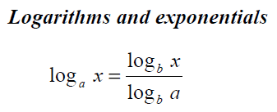
Excerpt from formula book that you may find useful:

- Sketch the graph of , showing clearly the coordinates of any intersections with the axes. State also the equations of any asymptotes. (3)
- Evaluate
You must give a reason for each answer to get the mark. (2)
- Simplify as far as possible
  - 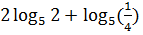
You must show your working. (7)
- Solve the following equations. Give your answers to 3 significant figures where appropriate.
  - (2)
  - (4)
  - (4)
  - (5)
  - (4)
  - (5)

- Show that
  - (2)
  - (2)
Total: 40 marks

